TỔNG HỢP ĐỀ K VÚ:

TỔNG HỢP ĐỀ K CTC:

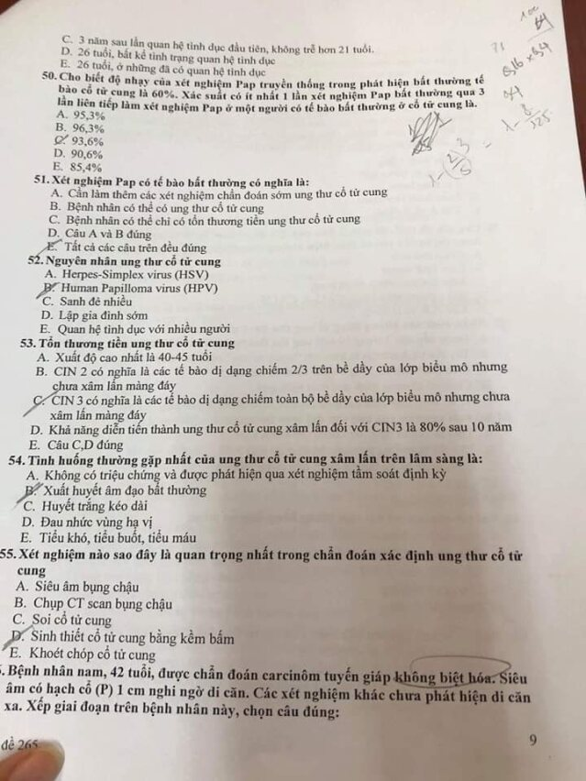

TỔNG HỢP ĐỀ K GIÁP:

Mã đề 265.



